**PROJECT REPORT OF**

# Digital Communication (TE-331)

# H:\SSUETLogo.jpg

**Project Title:**

**Multiple Input Multiple Output**

**(MIMO)**

**Group Members: Roll No:**

1. M.Ali Shaikh 2017-TE-027
2. M.Arsalan Mirza 2017-TE-028
3. Abdul Quyyum Qureshi 2017-TE-036
4. 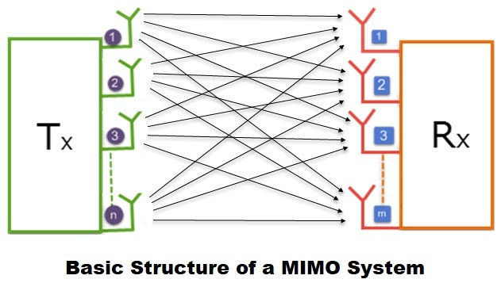Muhammad Ahmed Pathan 2017-TE-033

**SUBMITTED TO: Sir Irfan Ahmed Usmani**

**Telecommunication Engineering Department**

Sir Syed University Of Engineering and Technology

University Road Karachi - 75300

**MIMO:-**

MIMO (multiple input, multiple output) is an [antenna](https://searchmobilecomputing.techtarget.com/definition/antenna) technology for wireless communications in which multiple antennas are used at both the source (transmitter) and the destination (receiver). The antennas at each end of the communications circuit are combined to minimize errors and optimize data speed. MIMO is one of several forms of smart antenna technology, the others being [MISO](https://searchmobilecomputing.techtarget.com/definition/MISO) (multiple input, single output) and [SIMO](https://searchmobilecomputing.techtarget.com/definition/SIMO) (single input, multiple output).

MIMO technology has been standardized for [wireless LANs](https://en.wikipedia.org/wiki/Wireless_LAN), [3G](https://en.wikipedia.org/wiki/3G) mobile phone networks, and [4G](https://en.wikipedia.org/wiki/4G) mobile phone networks and is now in widespread commercial use. Greg Raleigh and V. K. Jones founded [Airgo Networks](https://en.wikipedia.org/wiki/Airgo_Networks) in 2001 to develop [MIMO-OFDM](https://en.wikipedia.org/wiki/MIMO-OFDM) chipsets for wireless LANs.

**Commands used in our Project:-**

clear all;

global num_channels alphabet num_antennas

num_channels=8;

alphabet=[+1 -1];

num_antennas=3;

imp_res_len=3;

channel=zeros(num_antennas,imp_res_len);

channel(1,:)=[0.7 0.5 0];

channel(2,:)=[0.7 -0.7 0.7+0.7j];

channel(3,:)=[0 0.7-0.7j 0.7+0.7j];

for i=1:num_antennas

R_ofdm=zeros(num_channels);

R_mccdm=zeros(num_channels);

H_ofdm=zeros(num_channels);

for j=1:i

[H_ofdmt,R_ofdmt,R_mccdmt,Fwt]=calc_R(channel(j,:));

R_ofdm=R_ofdm+R_ofdmt;

R_mccdm=R_mccdm+R_mccdmt;

end

R_ofdm=norm_R(R_ofdm);

R_mccdm=norm_R(R_mccdm);

plot_mat_ber(H_ofdm,R_ofdm,R_mccdm,Fwt);

end

**Block Diagram:-**



**Program Outputs**





**Conclusion:-**

MIMO technology has aroused interest because of its possible applications in digital television (DTV), wireless local area networks (WLANs), metropolitan area networks (MANs), and mobile communications.